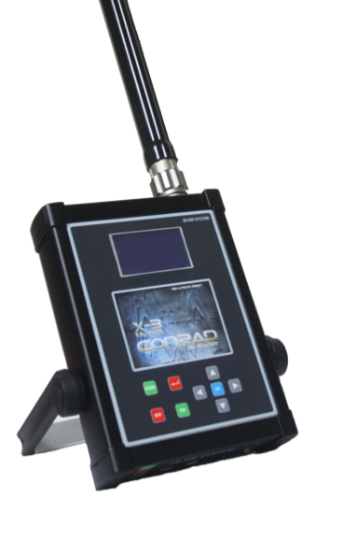
URRIGANE DEEP BLUE
Last Series

TECHNICAL FEATURES

- 128 MHz processor
- 1024 MB memory
- 12 v 5 A operating voltage
- 64 x128 pixels resolution
- Charged integrated battery
- Wireless,compact design main unit
- 16 memory storage function
- Metal detecting magnetometer
- Independent real time graphic transfer
- Background adjustment for easy usage in day and night
- Brightness and contrast adjustment
- Automatic and manual scan mode
- Signal range and velocity adjustment function
- 2000 meters ranged area scan system
- Gold,silver,copper,bronze,lead,aluminum,iron ,space,water and independent scan mode
- Distinction and transition functions over the programmed metals
- Automatic frequency balance feature accordingly to the soil nature

1 . Assembly
The assembly methods of device and its accessories are clarified in this section whereas the
assembly methods of searching sensor ,headset ,joystick and PC cable connections are
demonstrated in following Figure

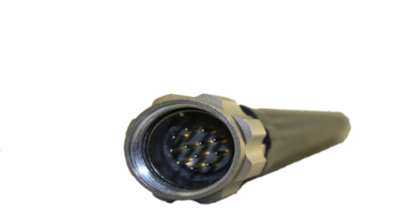
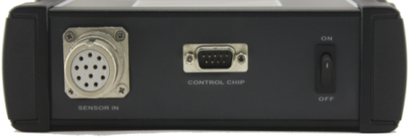

Figure 1: The sensor socket shall be installed by means of placing the edge upwards without using excessive force.

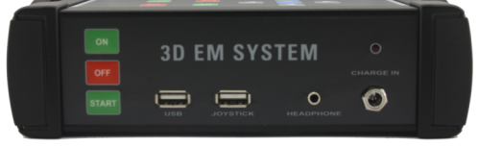
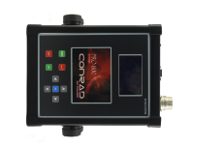
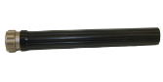

Figure 2:The view of installed sensor and front panel inputs.

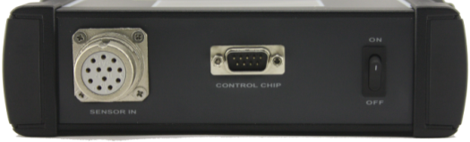
On/Off

EM Sensor input Earth device input socket for area scan
Figure 3:The view of installed sensor and read panel inputs .

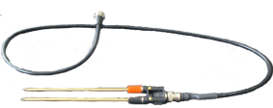
Figure 4:Connection cable of the earth device for area scan .

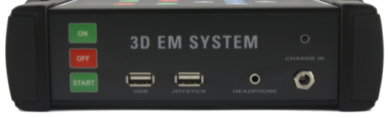
Led lamp of charge

On PC connection Headset input
Off 12 v charge adapter input
Signal start button Joystick input

Figure 5 :The front panel view of X 3 Ultra and connection devices

- Key used to activate the automatic and manual Button activation signal:
- connect the instrument to the PC PC Connection: USB input for
- connection to the joystick used to send signals to automatically search Input joystick port

- to use a headset Earphone: Input for

- is turned on while the power is being charged. LED charging indicator: This indicator
- Input battery charger. Input battery charger 12 v:

WARNING! Use only the battery charger supplied with the instrument. Never use a battery charger different. Otherwise it will damage the instrument.

2 Operating Modes

2.1Main Menu

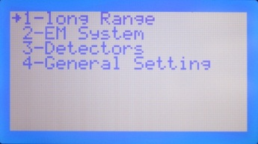

Figure 6: The view of X-3 Ultra main menu
- Long Range:
The long range area scan mode included in the main menu does not exist in the PRO 900 mode .It is active in upper models .
- Em System: You can execute all scanning processes in this menu of the PRO 900 model .
- Detectors: The Detector mode indicated in the main menu enables you to detect the metal dirt within soil.It detects all kinds of metals .
- General Setting :
The menu including the features that you can apply general adjustments for the product.

2.2 Long Range Menu:

Push the OK button on the device in order to work in this mode. You can switch to metal type you intend to scan by arrow keys .
The frequency values are automatically adjusted accordingly to every metal type.
You can change the frequency values as of every type refers to 0.1 KHz.

X-3 Ultra switches between the element programs mentioned below in its memory and balances the signal entered continuously accordingly to the earth type through the frequency balance feature .

2.2.1 Mode Selection of Area Scan System:

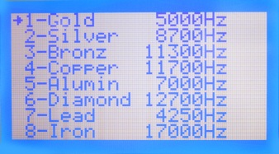

Figure 7: The view of area scan menu

Push the OK button after selecting the element you intend to scan .The frequency of selected element will be transferred to earth automatically .The frequency screen will appear as seen in Figure 8.

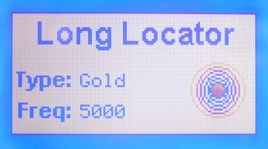

Figure 8:The view of frequency menu
1-GOLD 5.00 KHz:The low frequencies in gold spectrum attract the natural gold mines between 4.9 and 5.1 KHz and reacts for the bars at 5.2-5.3 KHz together with human produced gold materials of 18-22 carats.The frequencies of 5.4-5.5 KHz tend to attract the lower carat diamonds .Therefore ,it is requested to control with more than one device in different frequencies.During the du 1 control,adjust the device frequency to 5.00 KHz and scan again after waiting five minutes.If the bars point out,then it will refer to metal.
2-SILVER 8.70 KHz
3-BRONZE 11.30KHz
4-COPPER 11.70 KHz
5-ALUMIN. 7.00KHz
6-DIAMOND 12.70KHz
7-LEAD 4.25KHz
8-IRON 17.00KHz
9-WATER 10.00KHz
10-VOID 0.70KHz
11-FREE: 0-20.00 KHz(The mode that the user can select the intended frequency manually by using arrow keys).
As it is understood ,the molecular frequency will also be mentioned with the name of element in order to adjust the frequency on device.The frequencies above are required to be tested since the human factor has great influence .By using the arrow keys through the tests with simple purposes only in calibration ,the frequency provides the sensitivity for all operators .The device balances the frequencies vary accordingly to the earth structure and natural signal value of metal through the frequency balance feature and remove the faults arising from the frequencies in scans .
The bars are generally hold as stable and balanced slightly in front of the user equal to the waist .They are hold as parallel through indicating forward including the distance of 8-18 cm between each other. The individual has to find the most proper distance ,which can be acquired by trial and error method .Remember that the calm person will use the equipment more successfully than the nervous one.The indicator bars are mounted on power module in order to complete the required and adjusted receiver cycle .

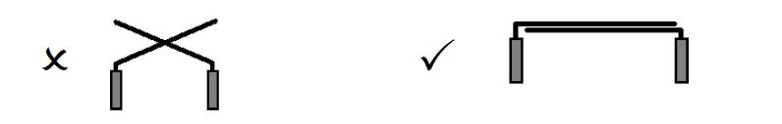
NOTE: The purpose of power module is to

operate the antenna bars.The power supply of unit includes 9VDC battery .The battery status will be indicated if short circuit is caused by bars whereas the battery shall be changed in case of inexistence of any volume .Open the bottom tap by turning in order to replace the battery of 9 volts .The power module operates by placing the receiver antenna bars to the power module socket.Remove the bars in case the bars are failed to be used .
The battery will be empty due to the reservation of power module with the bars installed .The bars shall not contact with each other when they are placed on module .Otherwise,the battery will cause the short circuit.
This cycle acts passively until the transmission line between the device and the aim operates physically .This RF (radio frequency)received from the transmission line interacts with the LC energy (inductive capacitance )operating cycle .The reaction in this point refers to the mutual attraction of bars by reaching the signal line between the device and target ,in other words , reaching in equal level .This process transmits to the operator that the intended target is at the range of target device physically.

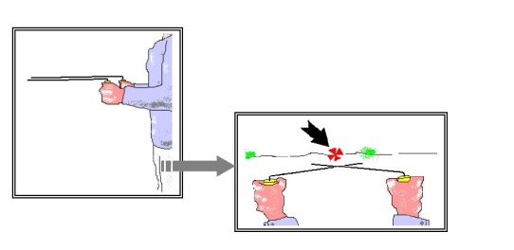

SAMPLE 1: Hold the bars slightly towards the bottom to achieve better balance or parallel to the ground to increase the sensitivity.

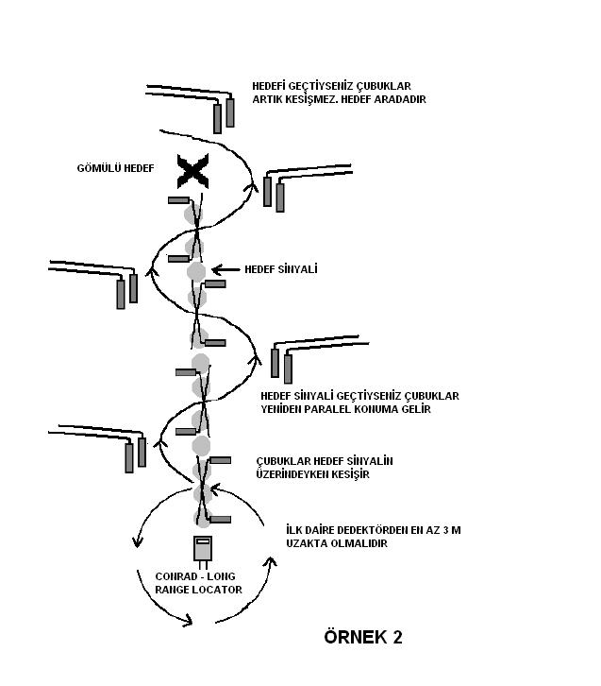

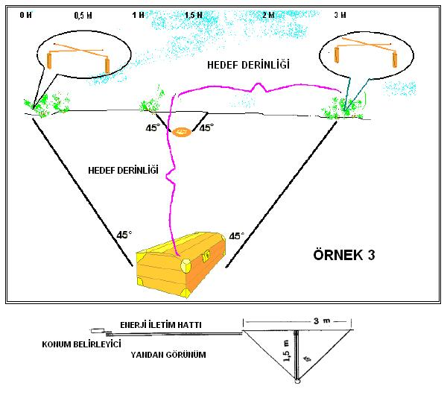
2.2.2 Depth Detection in Area Scan:Mark the intersection points of bars as soon as you reach the energy area of target by approaching from minimum two opposite directions (i.e. North/South)in order to determine the proper target depth when your CONRAD device is off.The half of distance between these 2 opposite directions refers to the approximate target depth .For instance ,it is 1.5 meters in Sample 3.However ,these methods are not applied for shallow targets .Consider that the energy area of target consists of a cone of 45 degrees from the target .Operating the main unit is not required for the depth detection whereas enabling the target to be visible from a certain distance is required for the establishment of transmission line functioning as a path for the operator.

2.3 EM System Menu:

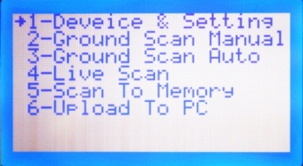

Figure 9: Sub-menu of the X 3 Ultra EM System

2.3.1 Devıce & Setting:
The sub-menu that you can apply the device selection ,signal sending time,selection of sensor and signal counts .

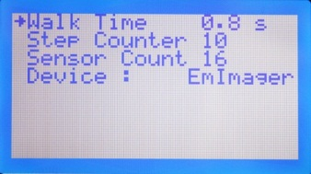

Figure 10 :The device selection and options section
- Walk Time:You can adjust the signal sending time in automatic scans.The ideal signal range is 1,4 seconds.
- Step Counter:You can adjust the signal count to be sent for every scanning line.Accordingly to the size of area to be scanned ,you can manually adjust the signal count by determining the value between 1 and 225.

You shall adjust the signal count by this menu for every area to be scanned .

- Sensor Count: Accordingly to the model of device used ,you can adjust the sensor count .The maximum sensor count is 16.
- Device:Refers to the menu that you can select the device model.The EMUltra system is used in both PRO 900 and X 3 Ultra models.

2.3.2 Ground Scan Manual:
The Ground Scan Manual mode refers to the scanning mode including the adjustment of signal count and signal transmission times by the user .In this scanning mode ,you can display the scan area in graphics in real time through PC.

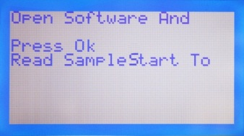

Figure 11:You can apply the PC adjustments and acquire images through the program in Ground Scan Manual.
You can activate this mode by pressing the OK button on the device .As it is seen in Figure 11,the device requests you to start the program and push the START button.

After applying the software and connection port adjustments used in PC ,you can start the data transfer by pushing the START button.You need to use the START buttons or JOYSTICK for every signal transmission .You can see the sequence and signal count status on the display image,as seen in Figure 12.

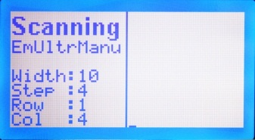

Figure 12:Ground Scan Manual mode
- Width: Indicates the signal count selected in the device and settings menu.
- Step:Indicates the total signal counts transmitted.
- Row:Indicates the scanning sequence applied .
- Col:Indicates the signal count transmitted for every sequence .

2.3.3 Ground Scan Auto :
The Ground Scan Auto mode refers to the automatic signal transmission mode including the adjustment of signal count and signal transmission times within period determined by the user.In this scanning mode,you can display the scan area in graphics in real time through PC.

Fıgure 13 : You can apply the PC adjustments and acquire images through the program in Ground Scan Auto mode.
You can activate this mode by pressing the OK button on the device .As it is seen in Figure 13,the device requests you to start the program and push the START button .
After applying the software and connection port adjustments used in PC ,you can start the data transfer by pushing the START button .You can see the sequence and signal count status on the display image ,as seen in Figure 14.

Figure 14:Ground Scan Auto mode

- Width:Indicates the signal count selected in the device and settings menu.
- Step:Indicates the total signal counts transmitted .
- Row:Indicates the scanning sequence applied.
- Col:Indicates the signal count transmitted for every sequence .

2.3.4 Lıve Scan:
By this mode ,you can work simultaneously and independently of certain step counts in PC software and acquire graphics in real time through the PC screen (max.2m). In order to work in this mode ,push the OK button on device.
As it is seen in the following Figure,you will be requested to push the START button after starting the program and applying the connection adjustments.

Figure 15:You can applythe PC adjustments and acquire images through the program in Ground Scan Auto mode.

After pushing the START button,the screen will appear as seen in Figure 16 and the simultaneous data transfer will start .Please view the graphic analysis section in the user manual for the interpretation and analysis of images .

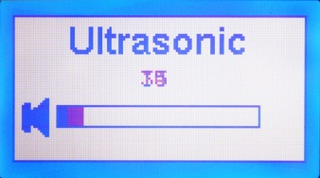

Figure 16:Transfer to PC screen during the live scan mode.

2.3.5 Scan to Memory:

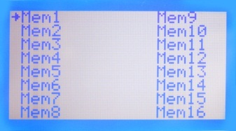

Figure 17:You can store 16 scans in memory through the Scan to Memory mode.
You can record your works in memory space selected (i.e Mem 1,Mem 2,etc.)in record to memory function and transfer these works to PC.Push the OK button through using the arrow keys in order to record in the memory you intend to include.You will be requested to select automatic or manual scan.
The scan will start in the Auto and Manual modes by means of your selection of signal count and time in the device and setting menu .You need to use the START buttons or JOYSTICK for every signal transmission .

2.3.6 Upload To PC :
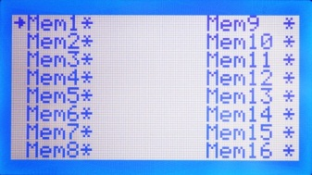

Figure 18:The fulfillment of works recorded in memory is indicated by the star sign.
In the Upload to PC mode ,you can transfer your previously recorded scans to PC .The star sign is placed near the full memory .Select the memory you intend to transfer by arrow keys and push the OK button .You will be requested to install the program and push the OK button again after connection setup.

Figure 19:You will be requested to push the START button in order to start the transfer through adjusting the program during transmitting the data within memory .
After pushing the START button ,the data will be transferred to PC.During the transfer ,UPLOAD TO PC will appear on the device screen .
2.4 General Setting Menu:

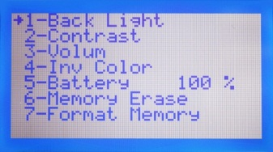

Figure 20:The menu you can apply the general adjustments of device.
The adjustments of screen light,brightness,volume and background color can be applied in the general setting menu and you can delete the data in memory separately or by formatting .
- Back Light:You can adjust the screen light by arrow keys.
- Contrast: You can adjust the screen contrast by arrow keys.
- Volume: You can adjust the volume of device by arrow keys.
- Background Color: You can adjust the background color by arrow keys.This function provides better display to the users for the day and night usage.
- Battery: You can see the battery usage time of device in this screen .

- Memory Erase:Refers to the menu that you can separately delete the data in memory .Push the OK button for the memory you intend to delete .Then push the OK again by selecting YES appearing on the next menu .Finally,the delete process will be completed.
- Format Memory:The menu enabling you to delete all data in memory.

3D DATA TRANSFER AND PROGRAM ADJUSTMENTS
1.General Information
In this section,you can be informed on the adjustments of connection points and data transfer to the PC software simultaneously or manually through using the EM system.
The 3D Ground Monitoring software is required to be installed in PC used for data transfer together with the products whereas the necesary connection adjustments are required to be applied .
The USB connection cable drive is detected automatically in Windows 7 and Windows Vista operating systems .In order to see the numer of port and drive adjustments,right click the My Computer icon.Click the Device Manager in the next window and then click Connection Points.Your connection point will appear on the screen displayed as USB Serial Port (Com....). The port number can be seen in the following Figure.

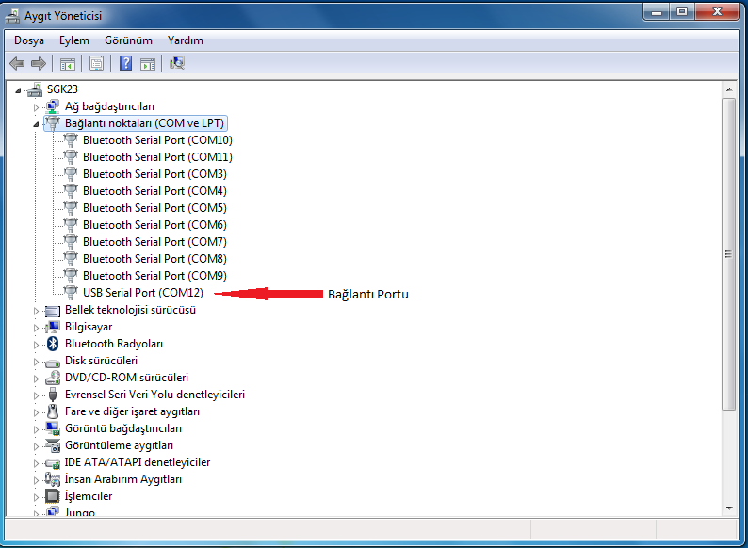

Please consult and receive information from your dealer or technical service in order to mount the USB driver in Windows XP operating systems.
You need to remember and remain the connection port.You will always need this connection port for the data transfer to PC.In the next section ,you can find the software adjustments and data transfer.

2.Program Adjustments and Data Transfer
2.1 Installation of 3D Program
The 3D Grounding Monitor program is required to be installed in your PC for the program adjustments and data transfer.Start the 3D Ground Monitoring program provided for installation .The loading codes will be requested in the installation screen .You can receive the activation codes for installation by telephone ,e-mail or the Conrad HQ office.
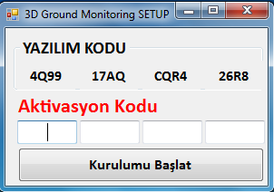

Figure2: Installation screen and activation code.

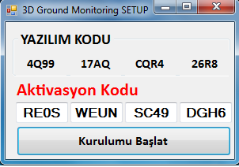

Figure 3:Fill the activation code in the installation screen.
The installation will start after you fill the activation code for installation.The installation screen will appear as seen in the following Figure.

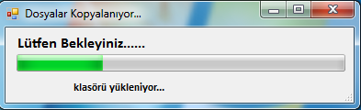

Figure4: Installation screen.The files will be uploaded to your PC.

2.2General View of the Program and Data Transfer
Start 3D Ground Monitoring program .The main menu of program will appear on the screen.In order to start the process and data transfer ,click New Project from the File menu or the New Project tab from the main menu.

Figure 5:Main menu of the 3D software.

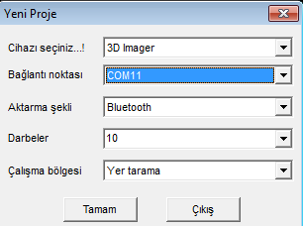

Figure 6:New project and connection adjustments.
Select the device system accordingly to the compliance of your device model through the Device Selection in new project section .
Connection point : As previously instructed in the adjustment section ,select the connection port of USB connection cable.
Transfer method:In this section ,select the transfer method complying with your device model .
Impacts:In this section ,select the signal count to be transmitted for every sequence .
Operating method: In this section ,select the operating method.
You can start the work and data transfer by applying all adjustments instructed above. You can transfer data by selecting Automatic or Manual on the device menu .Accordingly to your selection on device menu ,you will be required to open the software and push the START button.
You will be required to press the OK Button on the device as seen in the Figure below after applying the New Project adjustments in software .First,click OK in the New Project page in the PC software and then click OK on the device .Finally,push the START button in order to start the data transfer.

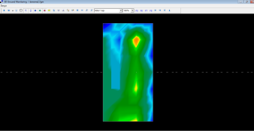

Figure 7:Send of data screen on the device and receive of data screen on PC.
The data transfer is applied similarly in Conrad PRO-800,PRO-900 and X-3 ULTRA models.Select the proper model for the device only by the device selection menu.
Same instructions specified in the user manual are required to be applied .You need to read and pay attention to all information in this manual in order to collect accurate data and avoid faults in your works.
In order to finish the data transfer ,push the BACK button on device .Push the STOP(X) sign in the new project section to stop the data transfer in software.
The data transfer shall comply with the optional live scan mode.You need to pick the live graphic selection in the operating method section of software in live scan function (for PRO-900 and X 3 Ultra models).
You need to read the GRAPHIC ANALYSIS AND INTERPRETATION (page 45) section carefully in order to analyze and interpret the collected data.You also need to start the works after applying and ensuring well analysis for the accurate interpretation of collected data.

WARNING!
- Do not remove the USB cable during the data transfer .
- Do not turn off the device during the data transfer.
- The battery charge level of your device affects the data transfer directly.The faults in data transfer happen due to the low battery .
- The data transfer shall be applied in compliance with the instructions stated above.
- The USB cable shall be applied in compliance with the instructions stated above .
- The USB cable shall be avoided against any damages or excessive use of force.

GRAPHIC ANALYSIS AND INTERPRETATION
1.General Information
- Device should be given some time in order to adapt ambient temperature after it is brought to working environment from different environments .
- Power supply should be in demanded values for efficiency and continuity of the signals.
- The main units of device are required to be charged for maximum 3 hours .
- The main unit and receiver sensor should not be damaged and should be protected against impacts
- In order to prolong expected life of the device ,it should be charged with its own charge unit and should not be charged more than its maximum charging time.
- It should be preserved in its original case as it is in electronic devices .
2 Scanning and Measurement Preparation
In order to conduct an accurate analysis with minimum mistakes ,the measured values of computer analysis program should be scanned as it is specified.Otherwise,analysis problem will occur and your studies will mislead you.
In EM Systems ,which refers to the Electro Magnetic Systems, the working principle of the products should be North-south .You should inside of North-south axis.
You should start scanning from starting point (1) as depicted in Figure 1 and finish it at the end point (2).
If you have finished a scanning line,the other one should be in the left .You should not rotate measurement device .North direction is recommended.

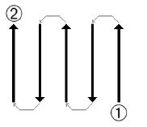

Figure1:Scan direction should start at 1 and end at 2 .

The more you repeat your scanning on a probable object (control scanning ),the better you decide whether it is a real object or not .Heat,other radio transmitters ,solar energy,ground minerals ,loose soil ,salt,water,etc.can adversely affect the measurement results .Sensor should be kept in vertical position to ground and should not be shaken .Its height to the ground should be 8-9 cm.

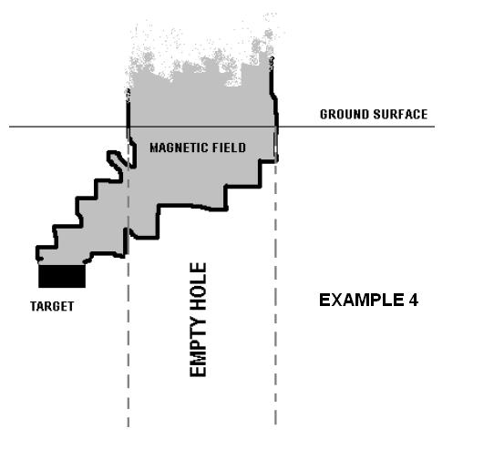

2.1 The Order of Signal Number
There is no specific rule regarding signal number .But there are different perspectives which are needed to be considered .These are,for example ,the length of measured area and the diameter of scanned object . The most convenient distance between two pulses is between 20 cm and 30 cm. the shorter the distance is between the pulses,the more accurate representative graphic will be. If you are searching for small objects,you need to choose small distance .If you are looking for big objects ,you should increase the distance between two pulses.

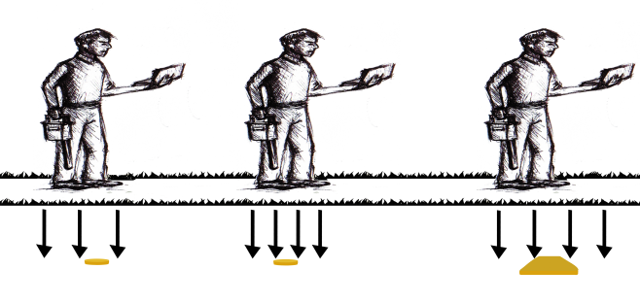

Figure 2:Signal space is of huge importance in detecting big and small objects .
You should wait for some time between two scanning to be made in the same point.In this way ,the electromagnetic pollution created will be dispersed .

3 The Analysis and Assessment of Measurements
You need to gather information about the area where the measurement will take place.For example ,the factors such as high-tension line,base station ,and electromagnetic pollutions should be at least 100 m away from working area.
If there is element to obtain accurate value regarding depth measurement ,it should be placed in the middle of object graphic .In order to be sure about your studies ,you should carry out at least triple control.The data received from the same place should be same with each other.
3.1 Metal Distinction
Metals are generally represented with red color but some mineral involving soil or debris can give red signals .For this reason ,it should be paid attention in the studies and you can distinguish the metals by considering the properties mentioned below:
- The metals generally have a specific structure such as triangle ,square ,rectangle,etc.This is the most distinctive property compared to mineral accumulations.
- If there are many different tones of yellow and orange around the red color in the graphic you obtained ,it is probably mineral.
- If there is red color obtained in the graphic in between 10 cm and depth ,it is high possibility that it is mineral.
- If each image acquired after control scans is same and if the depth and the feature of the object are same ,it is highly probable that it is metallic.

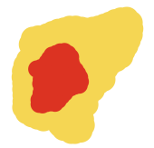
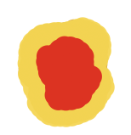

Figure 3: Metal (left)and mineral images (right)

